1.38: (The figure is given with the solution to Exercise 1.31).

The net northward displacement is (2.6 km) + (3.1 km) sin 45º = 4.8 km, and the net eastward displacement is (4.0 km) + (3.1 km) cos 45º = 6.2 km. The magnitude of the resultant displacement is 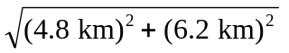 = 7.8 km, and the direction is arctan 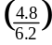 = 38º north of east.
